

FURTHER MATHEMATICS
TRIAL EXAMINATION 1
2011
SOLUTIONS

Section A Section B – answers

– answers

Core Module 1 Module 2 Module 3 Module 4 Module 5 Module 6
Number Geometry Graphs Business Networks Matrices
patterns and trig and related and
relations maths decision

maths
1. B 1. E 1. A 1. A 1. B 1. E 1. D
2. C 2. C 2. D 2. D 2. D 2. B 2. E
3. B 3. C 3. B 3. C 3. B 3. D 3. C
4. A 4. D 4. C 4. C 4. C 4. C 4. C
5. D 5. C 5. A 5. E 5. D 5. E 5. E
6. D 6. B 6. D 6. C 6. A 6. A 6. B
7. C 7. B 7. C 7. A 7. D 7. B 7. C
8. E 8. B 8. E 8. B 8. A 8. C 8. D
9. C 9. E 9. B 9. C 9. D 9. D 9. A
10. E
11. A
12. C
13. B

Core: Data analysis

Question 1

Write the data in order.

3 4 4 5 5 6 7 8 8 9
Q₁ Q₂ Q₃

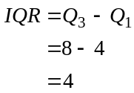
The answer is B.

Question 2

A bar chart is used to display categorical data. A histogram is used to display larger sets of data. A scatterplot is used to display data involving two variables not one. A parallel stem plot displays two sets of data not one.
The answer is C.
Question 3

The weights of the fish taken downstream are generally less than the weights of those taken upstream and more variable.
The answer is B.

Question 4

100% of the data for this sample lies between 400 and 600.
We know that 99.7% of data lies 3 standard deviations either side of the mean.
So
The closest standard deviation is 35.
The answer is A.

Question 5
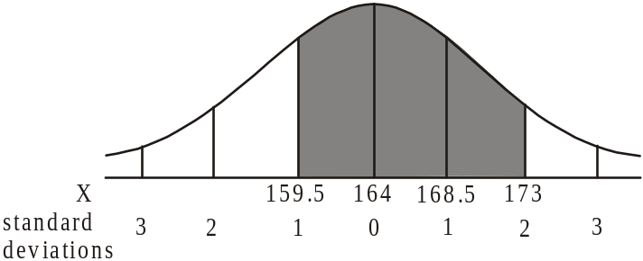

68% of scores lie between 1 standard deviation either side of the mean.
95% of scores lie between 2 standard deviations either side of the mean.
So 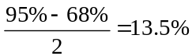 of scores lie between 1 standard deviation and 2 standard deviations above the mean.
So of the women have a height between 159.5cm and 173cm.
The answer is D.

Question 6

The percentage of full-time students who are female
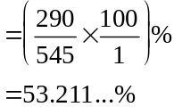
The answer is D.

Question 7

From the scatterplot, the regression line passes through the point with coordinates (84,61).
So the regression line predicts that an 84 year old resident will weigh 61kg.
The answer is C.

Question 8

The regression line that has been fitted passes through the points (75,68) and (100,49).
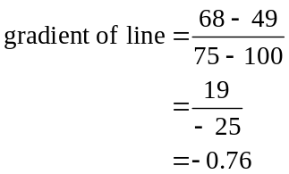
This eliminates options A, B and D.
Note that since the axes both start at values greater than zero, the “y-intercept” or vertical axis intercept is not 68 but a number greater than this. This eliminates option C.
The answer is E.

Question 9

Using CAS, enter the data and find a least squares regression line for against x.
The gradient of this line is -0.07129…
The closest answer offered is −0.07.
The answer is C.

Question 10

Given .
For the regression line 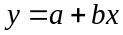,
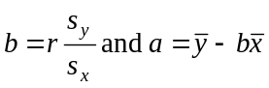 (from formula sheet)
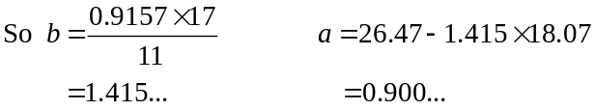
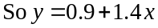 where a and b have been expressed correct to 1 decimal place.
The answer is E.

Question 11

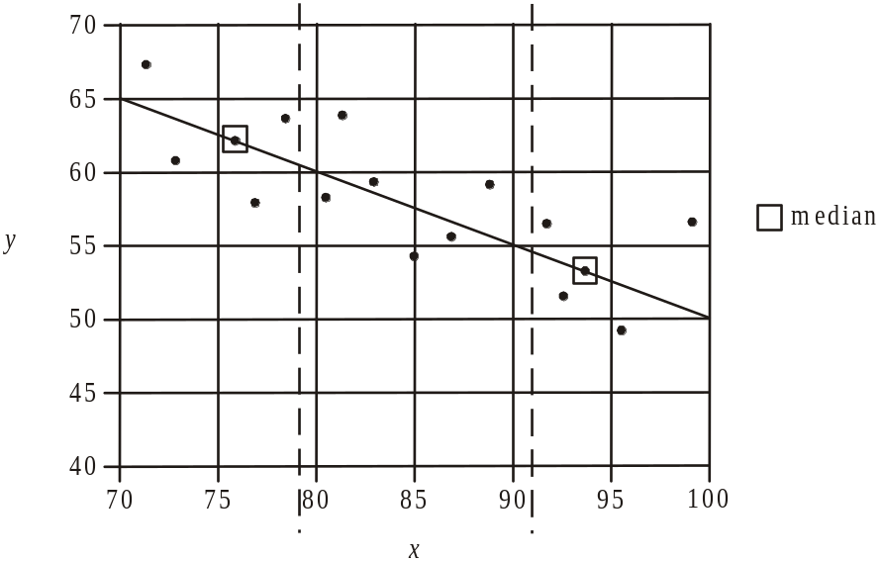

The line that passes through the median of the data values in the left hand group and the median of the data values in the right hand group is shown.
The gradient of this line is the same as the gradient of the 3 median line (since this line is just moved one third of the way towards the median of the middle group to obtain the 3 median line).
Since the line drawn passes through the points (70,65) and (100,50),
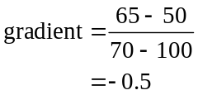
The answer is A.

Question 12

The time series plot shows a cyclical trend which repeats each 3 years. There is no clear upward or downward trend.
The answer is C.

Question 13

The winter seasonal index is
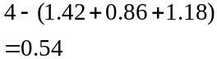
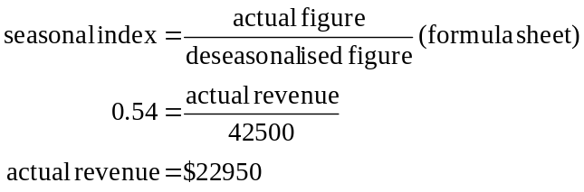
The answer is B.

SECTION B

Module 1: Number patterns

Question 1

Only option E has a common difference. That common difference is 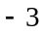. Note that options C and D are geometric sequences.
The answer is E.

Question 2

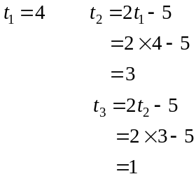
The answer is C.

Question 3

Since the sequence is geometric,
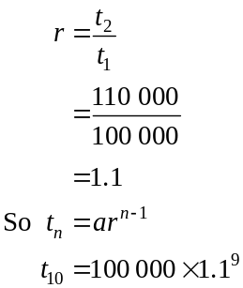
The closest answer is $235 795.
The answer is C.

Question 4

The sequence is Fibonacci related because a term (t_{n}) is generated by adding the previous two terms 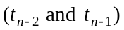.
So .
The answer is D.

Question 5

For the geometric sequence 120, −60, 30, −15, 7.5, … 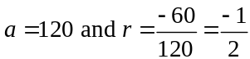.
The sum of an infinite geometric sequence with −1< r <1, is given by
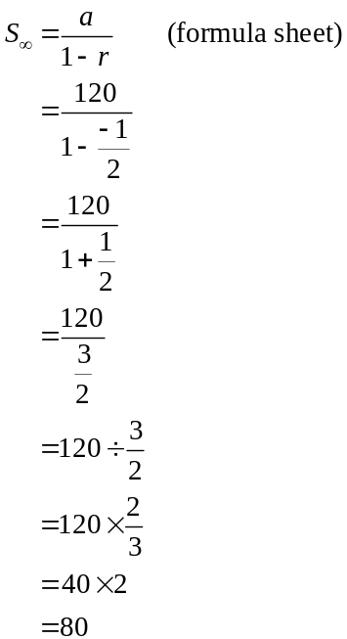
The answer is C.

Question 6

If 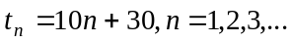 the sequence generated is 40, 50, 60, 70, …
So 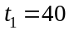. We can eliminate options A, C and D.
For option B, 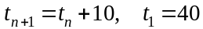 generates the sequence 40, 50, 60, 70, …
The answer is B.

Question 7

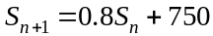

The amount of stock present in the warehouse at the start of the week is reduced by 20% to become 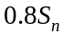. So 20% of stock is distributed to retail outlets and 750 items of stock are accepted for delivery at the warehouse.
The answer is B.
Question 8

For option A, the sequence is decreasing but by a larger amount for each successive term. This could not be the case for 0 <r <1 since each term decreases by a lesser amount for each successive term. The two graphs below show this decrease by a lesser amount for each successive term. The first graph shows the case where the first term is positive and the second graph shows the case where the first term is negative. The second graph is the same as option B.

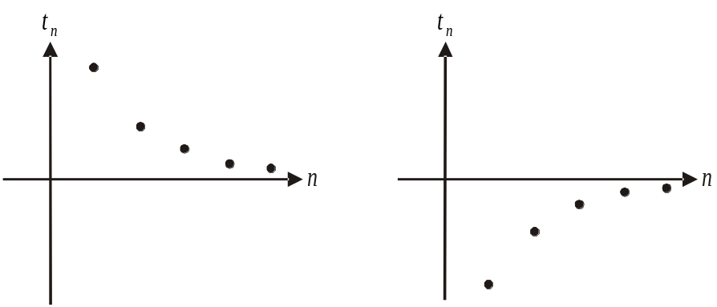

The answer is B.

Question 9

The distance between posts forms an arithmetic sequence with a (the first term) unknown and .
We know that the sum of the first 14 terms (note 15 posts with one at each end means 14 sections between posts) equals 595.
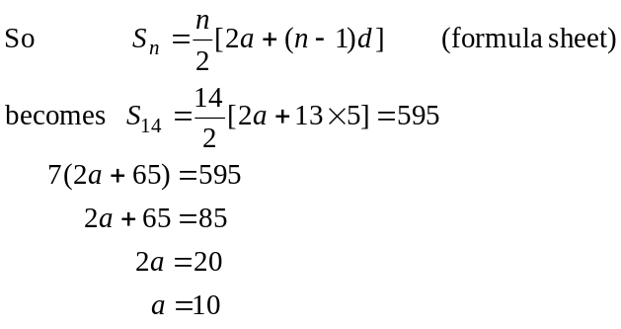
The largest distance is 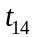.
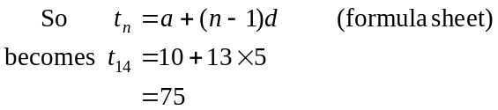
The answer is E.
Module 2: Geometry and trigonometry

Question 1
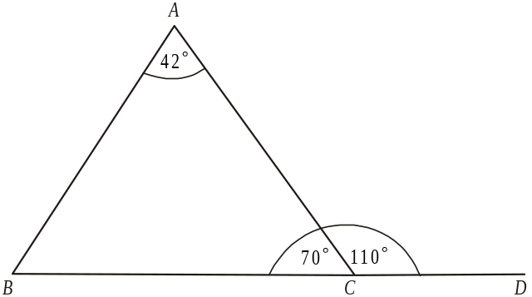

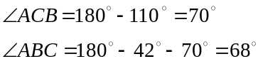

The answer is A.

Question 2

The obtuse angle CDE is an interior angle of the hexagon ABCDEF.
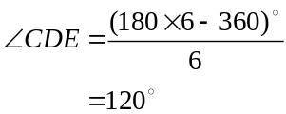
The answer is D.

Question 3

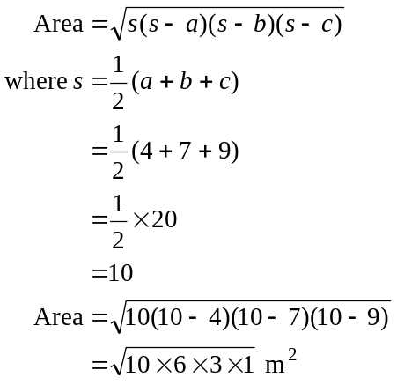
The answer is B.

Question 4

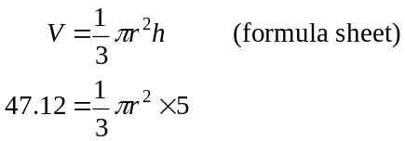
Method 1 – solve using CAS
Solve for r.
(Note r cannot be negative).
The closest answer is 3.
The answer is C.

Method 2 – by hand
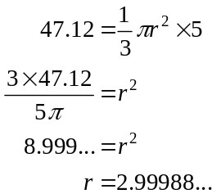
The answer is C.

Question 5

Let x = volume of small container.
The ratio of the heights is 4:5 so the ratio of the volumes is 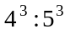.
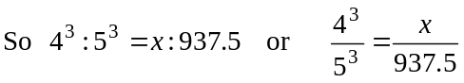
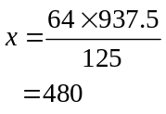
The answer is A.

Question 6

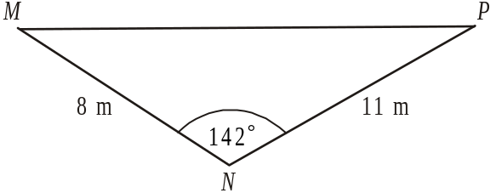

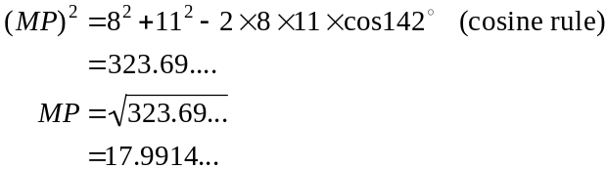
The closest answer is 18.
The answer is D.
Question 7

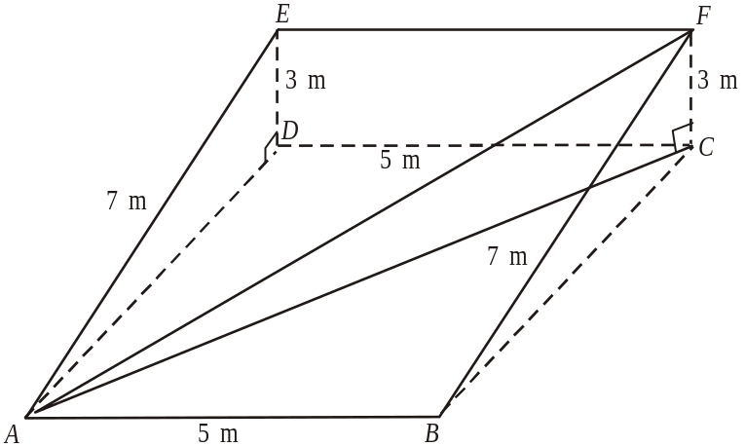

In ,
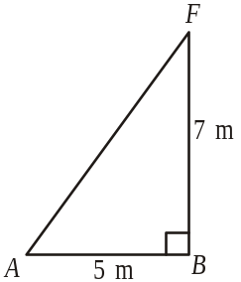
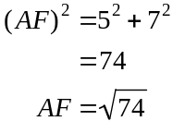

In ,
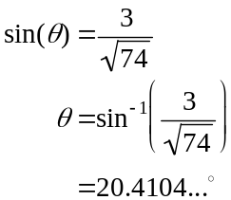
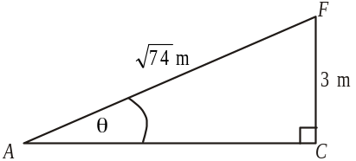
The closest answer is 20.4°.
The answer is C.

Question 8
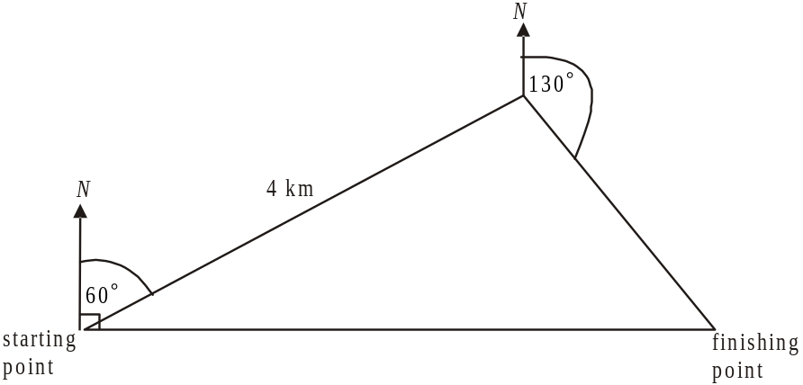

The information we are given is shown above.
From this we can add the following.
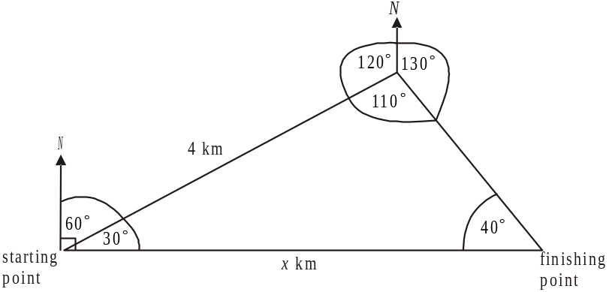

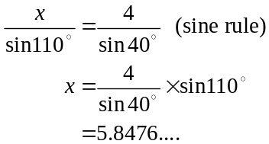
The closest answer is 5.8.
The answer is E.

Question 9

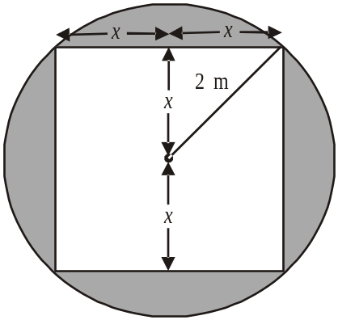

Let the sidelengths of the cloth be 2x.
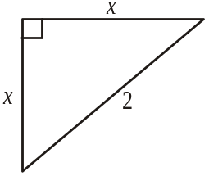
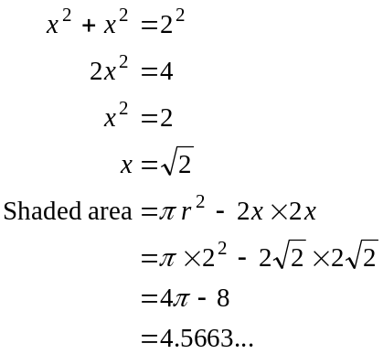
The closest answer is 4.6m².
The answer is B.

Module 3: Graphs and relations

Question 1

Method 1
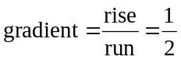

y-intercept is 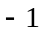.

where m is the gradient and c is the y-intercept
becomes 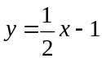
The answer is A.

Method 2
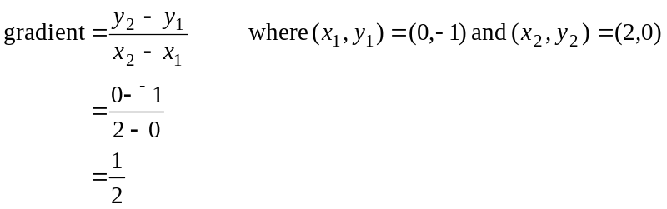
y-intercept is – 1.

where m is the gradient and c is the y-intercept
becomes
The answer is A.

Question 2

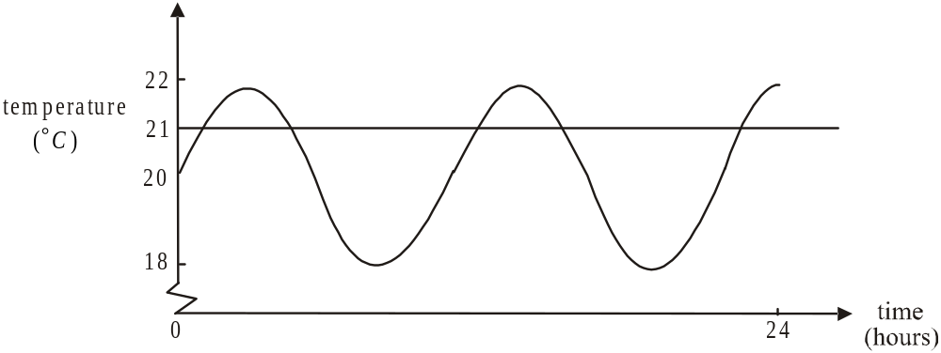

The number of times the temperature was 21°C during this period was five.
The answer is D.

Question 3

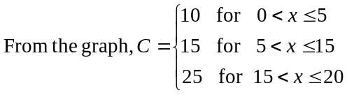
The answer is C.

Question 4

Method 1 – using CAS
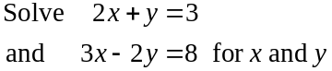
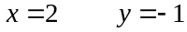
The answer is C.

Method 2 – by hand
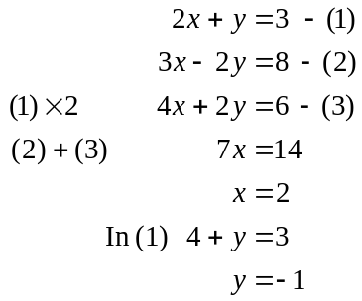

The answer is C.

Question 5

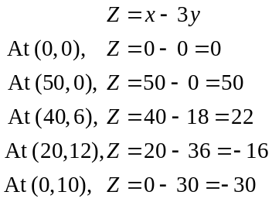
The minimum value of Z occurs at vertex E.
The answer is E.

Question 6

The relationship shown is 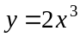.
All the options show a linear (straight line) relationship between 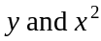 (options A and B) and 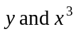 (options C, D and E). We can eliminate options A and B.
For C, the gradient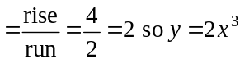 is the relationship.
The answer is C.

Question 7

The feasible region is shaded below.
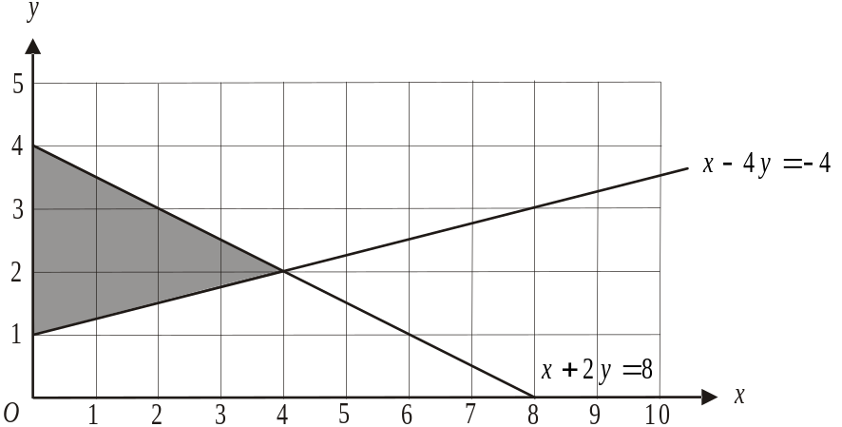

Of the points given, the only one that lies in the feasible region is (1,2).
The answer is A.

Question 8

The inequality relating to the amount Peter needs to earn per week is 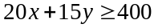.
The inequality relating to Peter’s preference for working at the café is 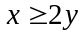.
The answer is B.

Question 9

The gradient of the given cost line is 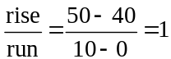.
The cost equation is therefore
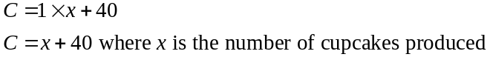
When , profit
When 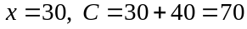
Now Profit=Revenue−Cost
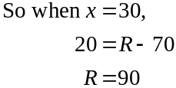
Since the revenue line passes through (0,0) and (30,90) the gradient of the revenue line is 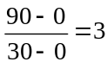.
So
At break even,
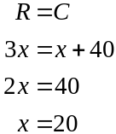
So 20 cupcakes need to be produced to break even.
The answer is C.
Module 4: Business-related mathematics

Question 1

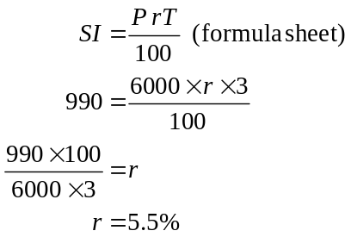
The answer is B.

Question 2

2% of $7500 = $150
The art dealer’s commission was $150.
The artist received 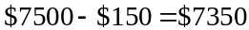
The answer is D.

Question 3

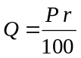
where Q is the fixed amount paid per annum, P is the amount invested, r is the annual interest rate
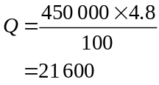
So the fixed monthly amount paid to the investor is 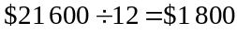
The answer is B.

Question 4

Amount owing after deposit is paid is 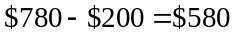.
The interest on borrowing $580 for 1 year at 6.2% per annum interest is 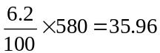.
The interest on borrowing $580 for 6 months at this interest rate is therefore $17.98.
An amount of 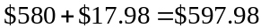 has to be paid in weekly instalments for 6 months.
So 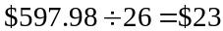 is the weekly instalment to be paid.
The answer is C.

Question 5

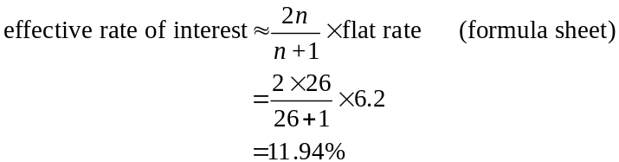
The closest answer is 12%.
The answer is D.

Question 6

Because the account earns compound interest, the amount in the account increases by an increasing amount each year. This is because interest is being calculated on the principal as well as the interest received in the previous years. Graphs A and B show the amount increasing each year by an increasing amount but graph B has the initial amount equal to zero. Since a fixed amount was invested initially the required graph is A.
The answer is A.

Question 7

Method 1
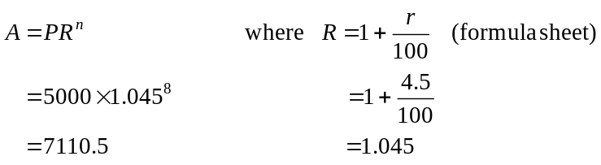
Note that annual interest is 9% so half yearly interest is 4.5%.
Also, the investment runs for 4 years, compounding half-yearly so .
The answer is D.

Method 2 – use TVM

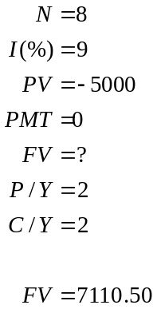

The answer is D.

Question 8

Use TVM

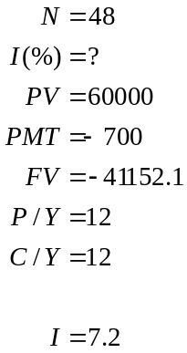
The answer is A.

Question 9

Use TVM

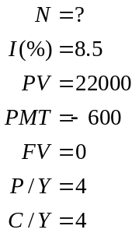

So Carl will make 71 payments of $600. We need to know how much of the principal is left after 71 payments have been made.

Use TVM again

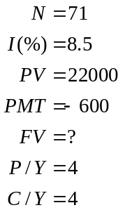

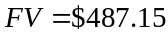

The closest answer is $487.
The answer is D.

Module 5: Network and decision mathematics

Question 1

The sum of the degrees is
The answer is E.

Question 2

A spanning tree must contain all the vertices of the original graph. This eliminates options C and D.
A spanning tree contains no loops. This eliminates options A and E.
The answer is B.

Question 3

Jacinta only offers to be president.
Tash only offers to be president or vice-president so since Jacinta has to be president, Tash will have to be vice-president.
Paula and Hayden offered to be secretary, treasurer or vice-president. Since the latter job is taken Paula and Hayden can either be secretary or treasurer.
The only answer that offers a feasible allocation is D.
The answer is D.

Question 4

Landmark C can be reached in two-steps by travelling along AGC, BDC, EDC, EFC, GFC.
The two-step reachability of landmark C is therefore 5.
The answer is C.

Question 5

There are three edges that pass from left to right across the cut. They have a capacity of 5, 7 and 8 respectively so the capacity of the cut shown is 20.
Note that two edges cross the cut from right to left (with capacity 6 and 4).
Since they are flowing in the wrong direction i.e. not from pond A to pond Z, we don’t count their capacities.
The answer is E.

Question 6

To find the maximum capacity through the network we look for the minimum flow.
Method 1 – by inspection

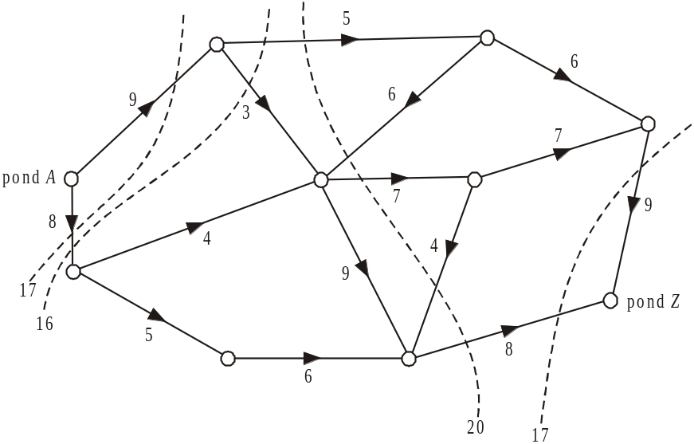

The minimum cut is 16 so therefore the maximum flow is 16.
The answer is A.

Method 2

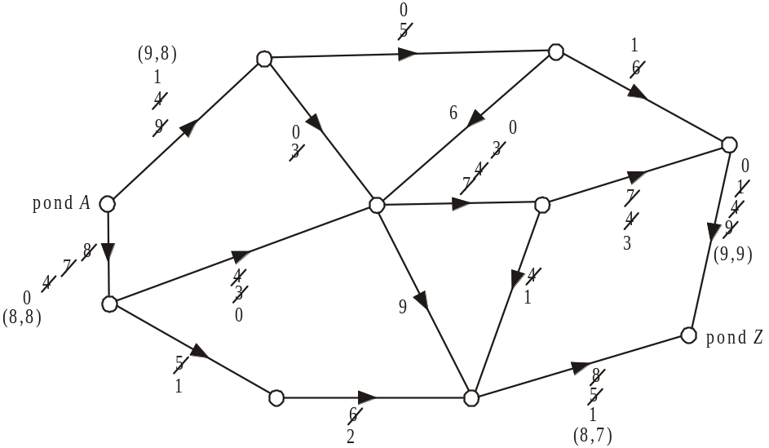

Start with the top path from pond A to pond Z and choose the arc with the least capacity. Subtract this from all the other arcs on the path.
Move to the next path and repeat the process until no paths exist which can carry flow.
Use the ordered pairs (initial capacity, final flow) to label the arcs leaving pond A and arriving at pond Z.
The maximum flow is the amount that flows out of pond A i.e. and into pond Z i.e. .
The answer is A.

Question 7

The graph can be redrawn, so that no edges cross.

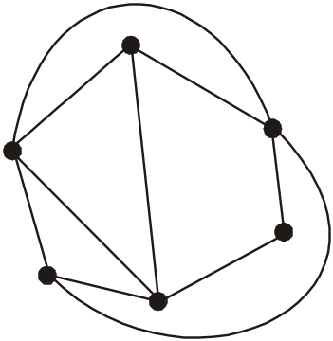

The graph is therefore planar and hence Euler’s formula can be applied.

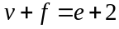 (formula sheet) where v (vertices) = 6 and e (edges) = 10.
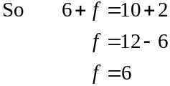
The answer is B.

Question 8

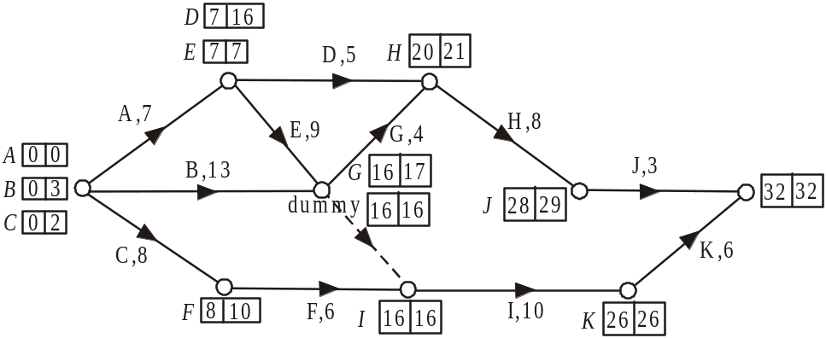

The earliest start times and latest start times are shown in the left hand and right hand sides of the boxes respectively for each activity.
For activity B, the float time (or slack time) is weeks.
The answer is C.

Question 9

Using the earliest start times and latest start times from the solution to Question 8 we see that the shortest completion time is 32 weeks.
The answer is D.
Module 6: Matrices

Question 1

If 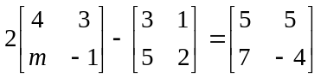

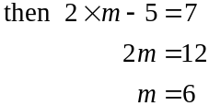
The answer is D.

Question 2

Matrix A is a matrix.
Matrix B is a matrix.
Matrix C is a matrix.

The only matrix product that is not defined is CB because the number of columns of C (i.e. 2) does not equal the number of rows of B (i.e. 1).
The answer is E.

Question 3

The order of matrix X is .
The order of matrix Y is .
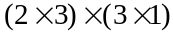
The order of the matrix product XY is .
The answer is C.

Question 4

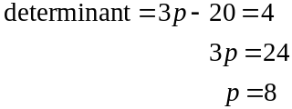
The answer is C.

Question 5

The simultaneous equations for this information are
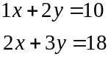

These equations can be expressed as a matrix equation.
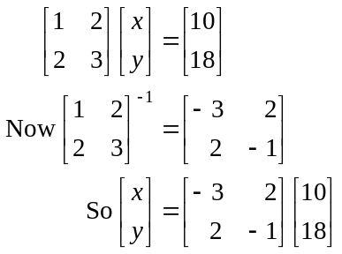
The answer is E.

Question 6

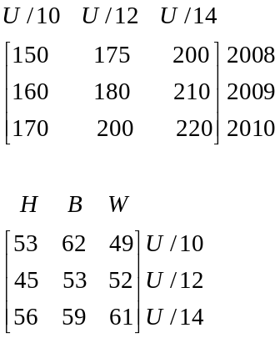

We need to multiply the 2nd row by the 3rd column.
The answer is B.

Question 7

All the employees at office B return there year after year so office B remains.
This is also the case at office D.
At office A, 70% return to office A and the rest go to offices B and D. Over time, the number of employees at office A will reduce to zero.
At office C, 50% return to office C and the rest go to either offices B or D. Over time, the number of employees at office C will reduce to zero.
Over the long term only 2 offices; B and D, will have employees located there.
The answer is C.

Question 8

Say the chef starts with a pasta.
The sequence will be
P F R C P F R C P F….
All the options are true except for option D.
The answer is D.

Question 9

Let S₁ be the state matrix for night 1.
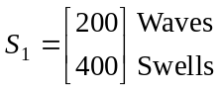
Let T be the transition matrix.

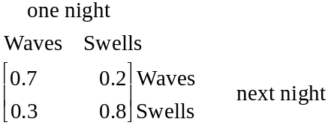

S₂ gives the number of passengers who eat at Waves restaurant and Swells restaurant on the second night.

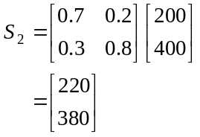
(check that the total is 600.)
The answer is A.

